Design Report
Assignment One - Personal Website
Web Development 1

Name | Juscyadila Da Silva
Student Number | 20111814
Course | Creative Computing
Group | Year 1

Website Overview
For my personal website I want a folder style homepage where the user can “explore the secret files” that lead to the following pages:
- Index: Homepage with four clickable links in the shape of files or folders
- About: Introduction, photo of myself, things I enjoy, goals and favourite quote
- Hobbies: list of hobbies, interests table, and more photos
- Goals: short term goals with images, another quote
- Contact: my social media links, LinkedIn and gmail address

Wireframes
Below are the wireframes I made for my website:

Index Page
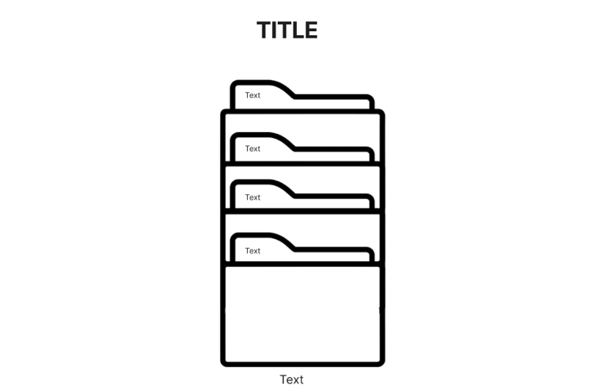

About Page
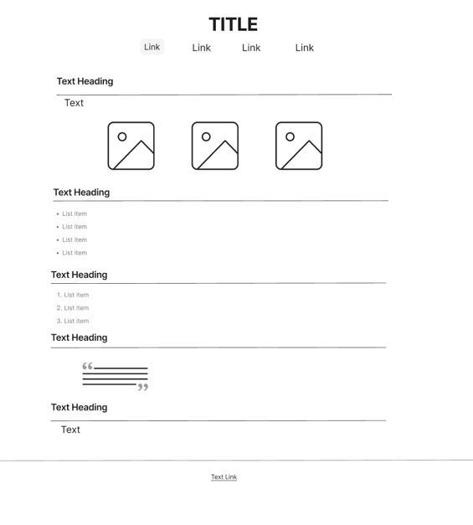

Hobbies Page
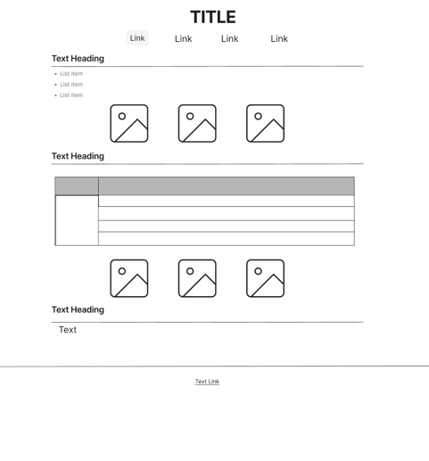

Goals Page
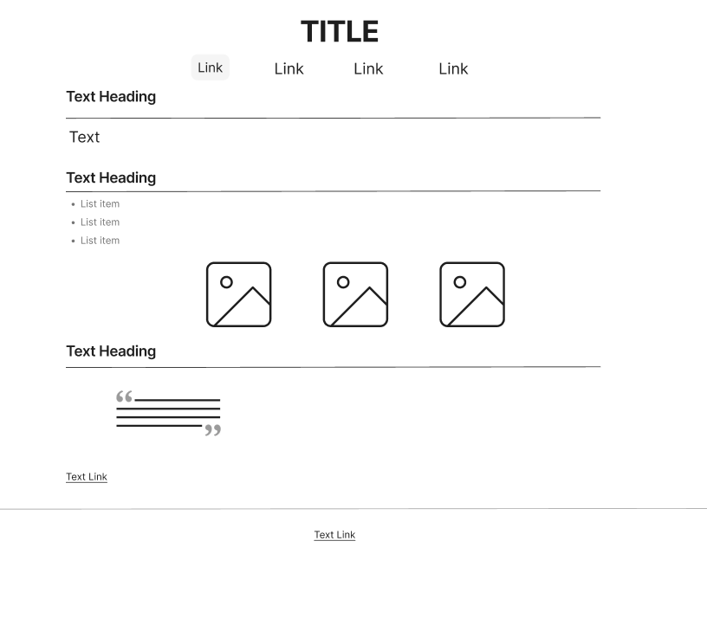

Contact Page

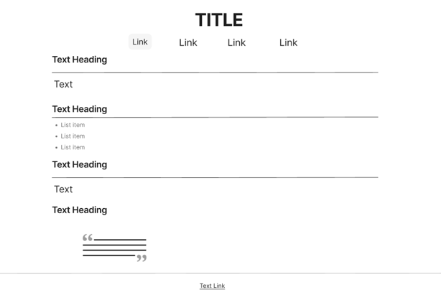

Visual Design
For my website I chose a sort of Neapolitan ice-cream colour pallet theme along with a forest green. I want to go for a very soft aesthetic look.
Colour Pallet
These are the colours I chose to use on my website
Colour | Hex Code | Used For
Warm Cream | #FDF0EF | Page background
Dark Brown | #4A3728 | Headings and text
Soft Pink | #F2C6C6 | Accents, nav hover, borders
Olive Green | #8A9A5B | Links and folder
Light Cream | #F5F0E1 | Blockquote background

Typography
- Primary font: Segoe UI
- External links will have an underline
- Text in quotes will be in italic

Website link:
https://juscy-webdev1-labs.netlify.app

